**UNIT – II**

**Fundamentals of AC circuits:**

R.M.S, Average valves, form factor and crest factor for different periodic wave forms, Sinusoidal Alternating Quantities - Phase and Phase Difference, Complex and Polar Forms of Representations, j-Notation. Concept of Reactance, Impedance, Susceptance and Admittance.

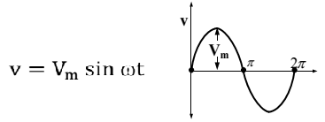**What is Alternating Voltage?**

Alternating voltage is the voltage which constantly changes in amplitude, and which reverses direction at regular intervals.

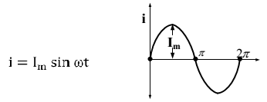**What is Alternating Current (A.C.)?**

When the current flowing in the circuit varies in magnitude as well as in direction periodically is called as an alternating current..

**Advantages of AC system over DC system**

1. AC voltages can be efficiently stepped up/down using transformer

2. AC motors are cheaper and simpler in construction than DC motors

3. Switchgear for AC system is simpler than DC system

**Types of Periodic Waveform**

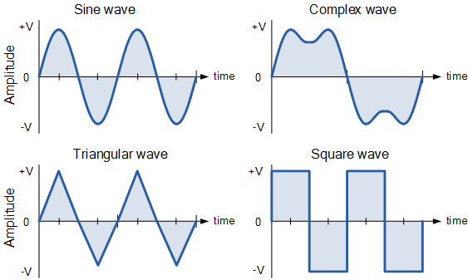

**Single Phase AC Generator**

There are two kinds of sources of electrical power:

(1) Direct current or voltage source (DC source) in which the current and voltage remains constant over time.

(2) Alternating current or voltage source (AC source) in which the current or voltage constantly changes with time. The voltage of the electrical power source that we use in our homes or offices (line voltage) is a sinusoidal signal that goes through a complete cycle 60 times in one second. In this section we will discuss how single phase AC voltage is generated.

Figure 2 shows a conductor placed in a magnetic field. A voltage is induced between its terminals (x, y) due to the change in flux linkage when the conductor is rotated in the magnetic field. The change in flux linkage is at its minimum when the conductor is moving parallel to the field and it is at its maximum when the conductor is moving perpendicular to the magnetic field. In a half rotation, the conductor moves from being parallel to the field to being perpendicular to the field and eventually moving back to being parallel to the field. Accordingly, the induced voltage increases from zero to its maximum value and then back to zero at the end of the half rotation.

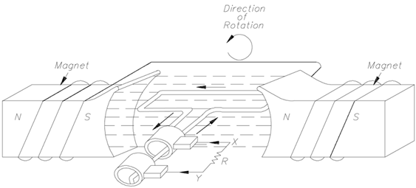

Figure 2: A rotating conductor in a magnetic field*.

Fig. 3 shows the changes in the induced voltage as the conductor rotates in the magnetic field.

During the second half of the rotation the flux linkage changes through the conductor the same way as before; however, it induces the voltage with the opposite polarity because the position of the conductors is now reversed. Due to the shape of the poles and the rotary motion of the conductor the induced voltage turns out to be a sine wave.

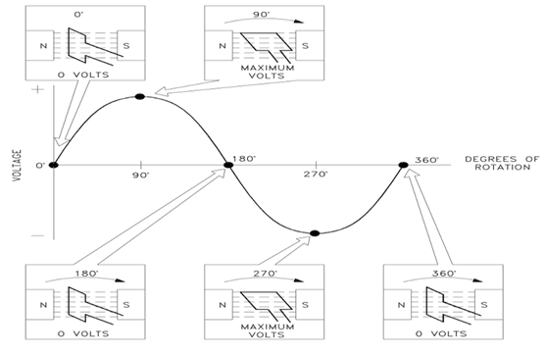

Figure 3: Induced voltage vs. rotation of the conductor*.

**Properties of Alternating Current**

**Frequency (f)**: It is the number of cycles that occur in one second. The unit for frequency is Hz or cycles/sec.

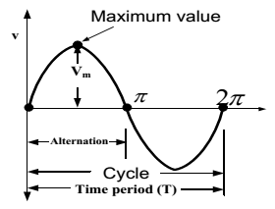**Period (T):** It is the Time Taken in seconds to complete one cycle of an alternating quantity.

**Wavelength (**λ)**:** wavelength is measured in distance per cycle.

λ= c/f.

**Amplitude:** The amplitude of a sine wave is the value of that sine wave at its peak. This is the maximum value, positive or negative, that it can attain.

**Peak-Peak value:** The difference between the peak positive value and the peak negative value is called the peak-to-peak value of the sine wave. This value is twice the maximum or peak value of the sine wave.

**Instantaneous Value:** It is the value of the quantity at any instant.

**Average Value**

The arithmetical average of an alternating quantity over one cycle is called its average value. Average Value can be determined by Graphical Method or Analytical Method.

From Fig (1) average value can calculate by using graphical method as.

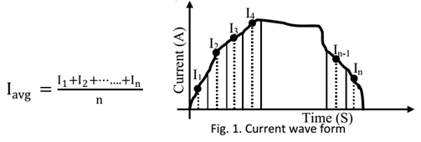

From Fig (2) average value can calculate by using Analytical method as.

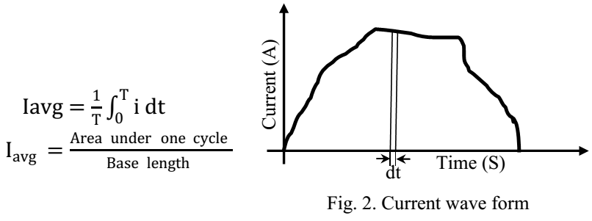

**RMS Value or Effective Value**

The effective or RMS value of an alternating current is the steady current (D.C) which when flowing through a given resistance for a given time produces the same amount of heat as produced by a alternating current when flowing through the same resistance for the same time.

RMS Value can be determined by Graphical Method or Analytical Method.

Graphical Method: This method is best suitable for complicated waveforms, with this method approximate RMS value can calculate very easily.

From fig (1) RMS value can calculate as

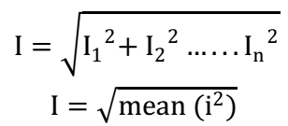

From fig (2) RMS value can calculate as.

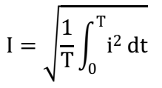

Where ‘I’ is the RMS value of alternating current, ‘i’ is the instantaneous value of current and where T is the time period.

**Peak Factor (or) Crest Factor**

The peak factor of an alternating quantity is defined as the ratio of its maximum value to the RMS value.

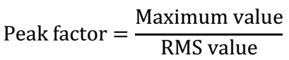

**Form Factor**

The form factor of an alternating quantity is defined as the ratio of RMS value to the average value.

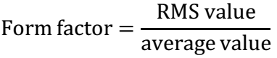

**Phasor**

A phasor is a line of definite length rotating in anti-clock wise direction at a constant angular velocity (ω). Length of this phasor is the maximum or RMS value of the alternating quantity.

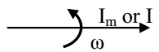

**RMS and Average Value for Sinusoidal alternating quantity**

**Maximum Value:** Maximum value of the given wave form is Imax= Im

**RMS Value**

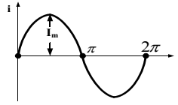The given wave form is a symmetrical wave form with a time period 2π.

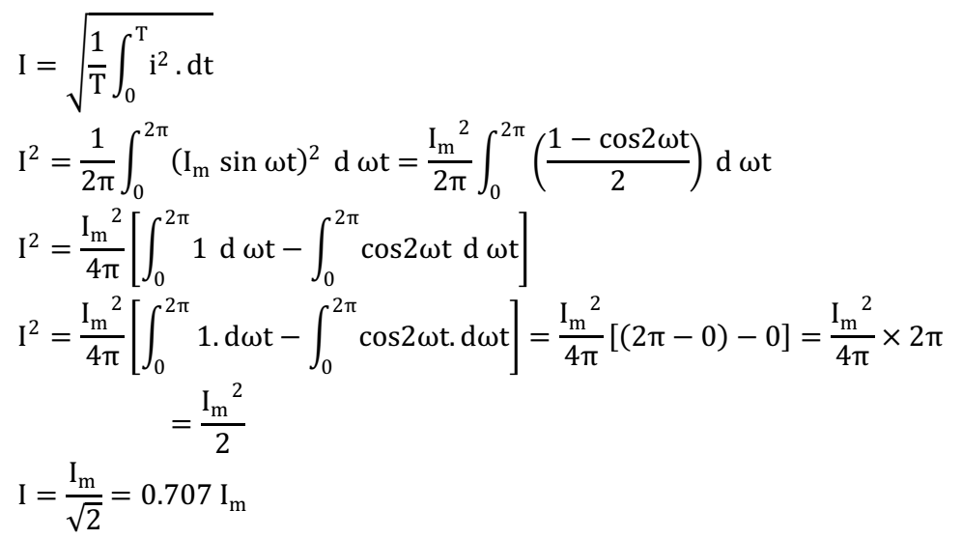

**Average Value**

The given wave form is a symmetrical wave form, consider only alternation.

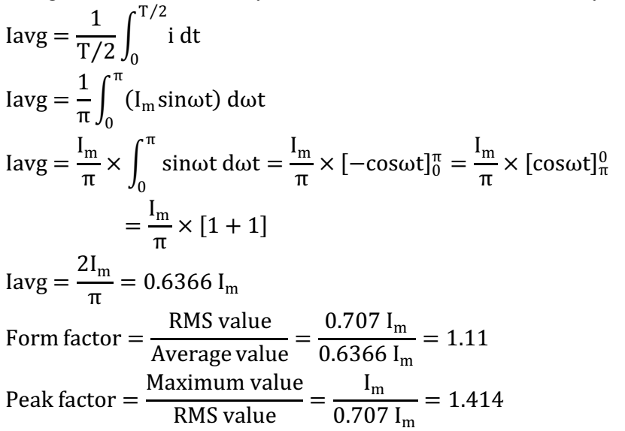

**Phasor Representation:**

An alternating quantity can be represented using

i) Waveform

ii) Equations

iii) Phasor

A sinusoidal alternating quantity can be represented by a rotating line called a Phasor. A phasor is a line of definite length rotating in anticlockwise direction at a constant angular velocity

The waveform and equation representation of an alternating current is as shown. This sinusoidal quantity can also be represented using phasors.

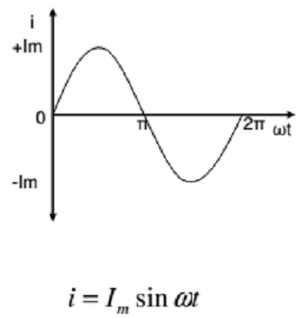

In phasor form the above wave is written as 

Draw a line OP of length equal to Im. This line OP rotates in the anticlockwise direction with a uniform angular velocity ω rad/sec and follows the circular trajectory shown in figure. At any instant, the projection of OP on the y-axis is given by OM=OPsinθ = Imsinωt. Hence the line OP is the phasor representation of the sinusoidal current.

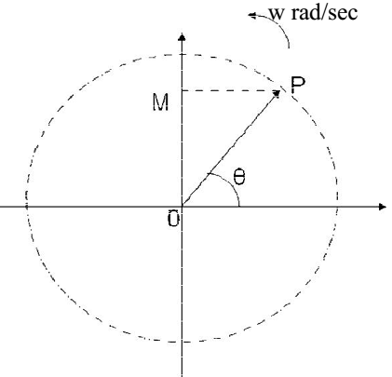

**Phase**

Phase is defined as the fractional part of time period or cycle through which the quantity has advanced from the selected zero position of reference

Phase of +Em is π/2rad or T/4 sec

Phase of -Em is π/2rad or 3T/4 sec

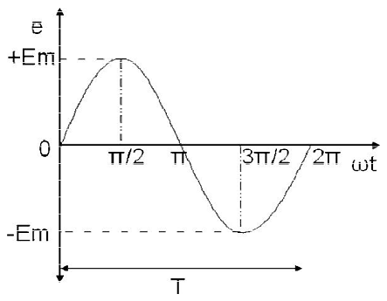

**Phase Difference**

When two alternating quantities of the same frequency have different zero points, they are said to have a phase difference. The angle between the zero points is the angle of phase difference.

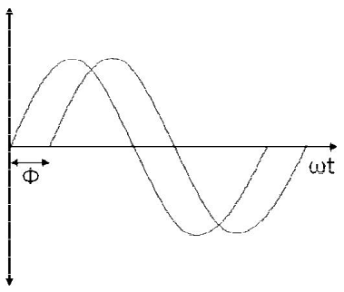

**In Phase**

Two waveforms are said to be in phase, when the phase difference between them is zero.

That is the zero points of both the waveforms are same. The waveform, phasor and equation representation of two sinusoidal quantities which are in phase is as shown. The figure shows that the voltage and current are in phase.

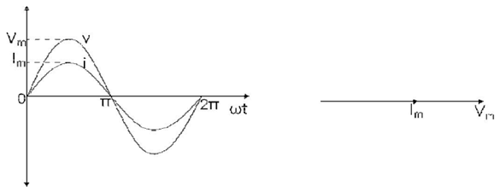



**Lagging**

In the figure shown, the zero point of the current waveform is after the zero point of the voltage waveform. Hence the current is lagging behind the voltage. The waveform, phasor and equation representation is as shown.

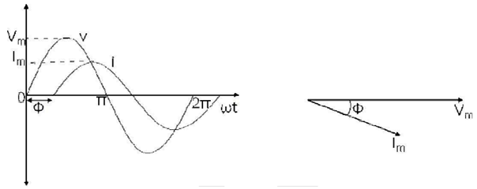

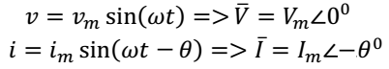

**Leading**

In the figure shown, the zero point of the current waveform is before the zero point of the voltage waveform. Hence the current is leading the voltage. The waveform, phasor and equation representation is as shown.

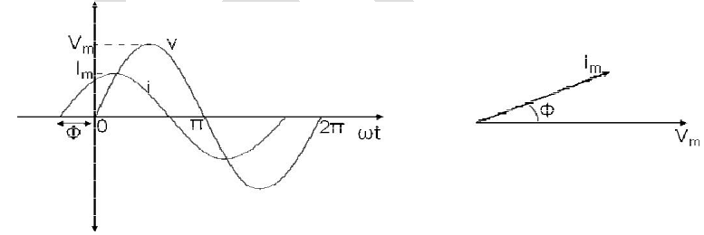

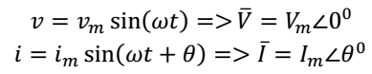

**Complex Numbers in Rectangular and Polar Form**

To represent complex numbers x+yi geometrically, we use the rectangular coordinate system with the horizontal axis representing the real part and the vertical axis representing the imaginary part of the complex number.

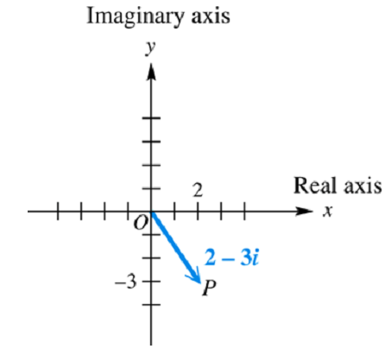

We sketch a vector with initial point (0, 0) and terminal point P(x, y). The length r of the vector is the absolute value or modulus of the complex number and the angle Ѳ with the positive x-axis is the is called the direction angle or argument of x+ yi.

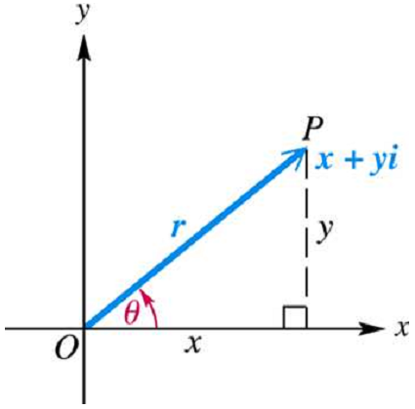

Conversions between rectangular and polar form follows the same rules as it does for vectors.

**Rectangular to Polar**

For a complex number x+yi

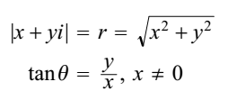

**Polar to Rectangular**

x = r cosѲ

y r sin Ѳ

The polar form r(cosѲ + i sinѲ) is sometimes abbreviated r cis Ѳ

and written as and read as “r at an angle Ѳ”

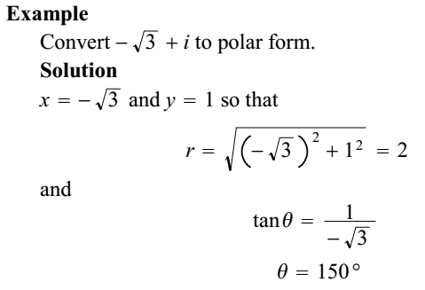

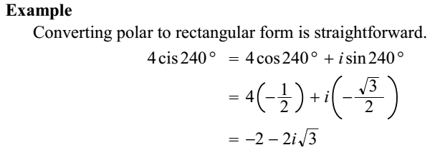

### Addition and Subtraction of complex numbers

To add or subtract two complex numbers, you add or subtract the real parts and the imaginary parts.

(a + bi) + (c + id) = (a + c) + (b + d)i.

(a + bi) - (c + id) = (a - c) + (b - d)i.

**Example 1:**

(3 - 5i) + (6 + 7i) = (3 + 6) + (-5 + 7)i = 9 + 2i.

(3 - 5i) - (6 + 7i) = (3 - 6) + (-5 - 7)i = -3 - 12i.

**Product and Quotient Theorems**

The advantage of polar form is that multiplication and division are easier to accomplish.

**Product Theorem**



**Quotient Theorem**

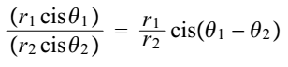

The advantage of using polar form will become even more pronounced when we calculate powers.

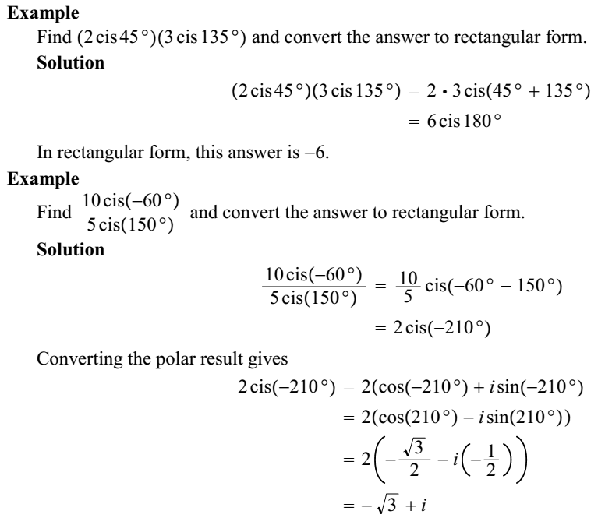

***MPEDANCE :***

*“Impedance is the total resistance/opposition offered by the circuit elements to the flow of alternating or direct current!”*

*OR*

*“The impedance of a circuit is the ratio of the phasor voltage (V) to the phasor current (I)”*

It is denoted by Z.

Z=V/I

[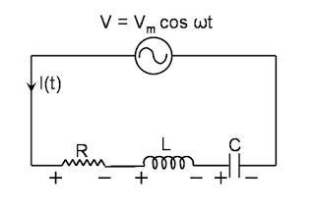](http://3.bp.blogspot.com/-YLhMKCgTSk4/VaU6NLoHQHI/AAAAAAAABH0/boHbx_S6h_I/s1600/1.png)

As complex quantity, we can write as:

Z=R+jX

It is a vector (two-dimensional) quantity consisting of two independent scalar (one-dimensional)phenomena: resistance and reactance !  
  
RESISTANCE:

*“Resistance of an element denotes its ability to resists the flow of electric current”*

OR

*“It is a measure of the extent to which a substance opposes the movement of electrons among its atoms”*

It is denoted by R.

The more easily the atoms give up and/or accept electrons, the lower the resistance, which is measured in ohms.

It is observed with alternating current (AC) and also with direct current (DC).

***Types of Resistance:***

·        HIGH RESISTANCE:

Substances with High-resistance are called insulators or dielectrics, and include materials such as polyethylene, mica, and glass.

·        LOW RESISTANCE:

Substances with low-resistance are called electrical conductors, and include materials such as copper, silver, and gold.

·        INTERMEDIATE RESISTANCE:

Substances with intermediate levels of resistance are called semiconductors, and include materials such as silicon, germanium, and gallium arsenide.

REACTANCE:

*“Reactance is a form of opposition that electronic components exhibit to the passage of AC (alternating current) because of capacitance or inductance”*

It is denoted by X.

It is expressed in ohms.

It is observed for AC (alternating current), but not for DC (direct current).

***TYPES OF REACTANCE:***

·        INDUCTIVE REACTANCE:

 When AC (alternating current) passes through a component that contains reactance, energy might be stored and released in the form of a magnetic field which is known as inductive reactance.

It is denoted by +jXL

·        CAPACITIVE REACTANCE:

 When AC (alternating current) passes through a component that contains reactance, energy might be stored and released in the form of an electric field which is known as capacitive reactance.

It is denoted by -jXC

**EXPLAINATION:**

 Reactance is conventionally multiplied by the positive square root of -1, which is the unit imaginary number called the j operator, to express Z as a complex number of the form R + jXL(when the net reactance is inductive) or R - jXC (when the net reactance is capacitive).

***ADMITTANCE:***

*“Admittance is the allowance of circuit elements to the flow of alternating current or direct current “.*

OR

*“It is the inverse of impedance”*

It is denoted by Y.

We can write as:

Y=1/Z=I/V

As complex quantity, we can write as:

Y=G+jB

Admittance is a vector quantity comprised of two independent scalars

phenomena: conductance and [susceptance](http://whatis.techtarget.com/definition/susceptance)  
  
CONDUCTANCE:

*”Conductance is the ability of an element to conduct electric current.”*

*OR*

*“It is the inverse of resistance”*

It is denoted by G.

G=1/R

The more easily the charge carriers move in response to a given applied electric potential, the higher the conductance, which is expressed in positive real-number (Siemens) or (Mhos).

 Conductance is observed with AC and also with direct current DC.

SUSCEPTANCE:

*”Susceptance is an expression of the readiness with which an electronic component, circuit, or system releases stored energy as the current and voltage fluctuate”*

OR

*“It is a reciprocal of reactance”*

It is denoted by B.

B=1/X

Susceptance is expressed in imaginary number Siemens.

Susceptance is observed with AC, but not for DC.

***TYPES OF SUSCEPTANCE:***

·        INUDUCTIVE SUSCEPTANCE:

When AC (alternating current) passes through a component that contains susceptance, energy might be stored and released in the form of a magnetic field which is known is inductive susceptance.

It is denoted by - jB L

·        CAPACITIVE SUSCEPTANCE:

When AC (alternating current) passes through a component that contains susceptance, energy might be stored and released in the form of an electric field which is known is capacitive susceptance.

It is denoted by + jB C

**EXPLAINATION:**

Admittance is the vector sum of conductance and susceptance. Susceptance is conventionally multiplied by the positive square root of -1, the unit imaginary number called symbolized by j , to express Y as a complex quantity G - jB L(when the net susceptance is inductive) or G + jB C (when the net susceptance is capacitive).

In parallel circuits, conductance and susceptance add together independently to yield the composite admittance. In series circuits, conductance and susceptance combine in a more complicated manner. In these situations, it is easier to convert conductance to resistance, susceptance to reactance, and then calculate the composite impedance.

***Impedance & Admittance:***

|  |  |  |
| --- | --- | --- |
| ELEMENT | IMPEDENCE  Z=V/I | ADMITTANCE  Y = I/V |
| R | **ZR**= R | **YR**= 1/R |
| L | ZL= jwL | **YL**= 1/jwL |
| C | **ZC**= 1/jwC | **YC**= jwC |